
Assignment #8 Summer 2018

60-212 OOP Using Java

School of Computer Science,

University of Windsor

Due: Monday, July 30th, 2018 at noon.

Note: To submit your assignment (and all other assignments/labs), create a zip with all source files (.java, NOT .bin!!) and any other necessary files (for instance, input files), and submit it on Blackboard. If the solution is only one file, zipping is not necessary. Your submission will only be graded if you attended lab the week this was assigned.

10 Marks, 2% of grade

In this assignment, you will create a very basic but functional Tic-Tac-Toe game. The first move must draw an X, the next must draw an O, and so on. You must not be able to overwrite a position that is already filled on the board. You do not need to check for game completion, the game simply ends when the board is full. I have provided a documented example which you should use as your starting point. See the comments for implementation hints and details. When a button is pressed down, the X or O should be drawn in the appropriate position, but it must not be committed until the mouse is finally released. That is, a player should be able to drag the mouse inside of the grid and the X or O should follow their cursor.

Example Gameplay:

Starting Board:

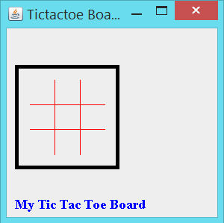

Player 1 clicks top-left…

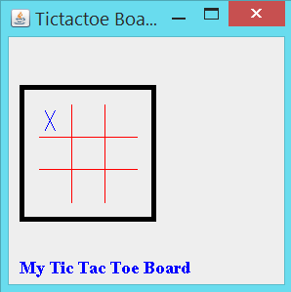

Player 2 clicks center…

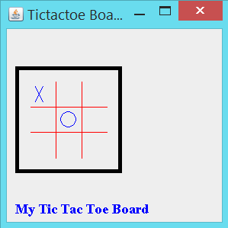

Player 1 clicks bottom-right…

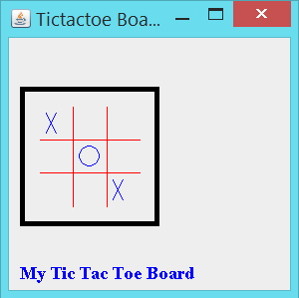

Player 2 clicks top-left… (nothing happens, it’s still player 2’s turn until they commit a valid entry)

Etc.

